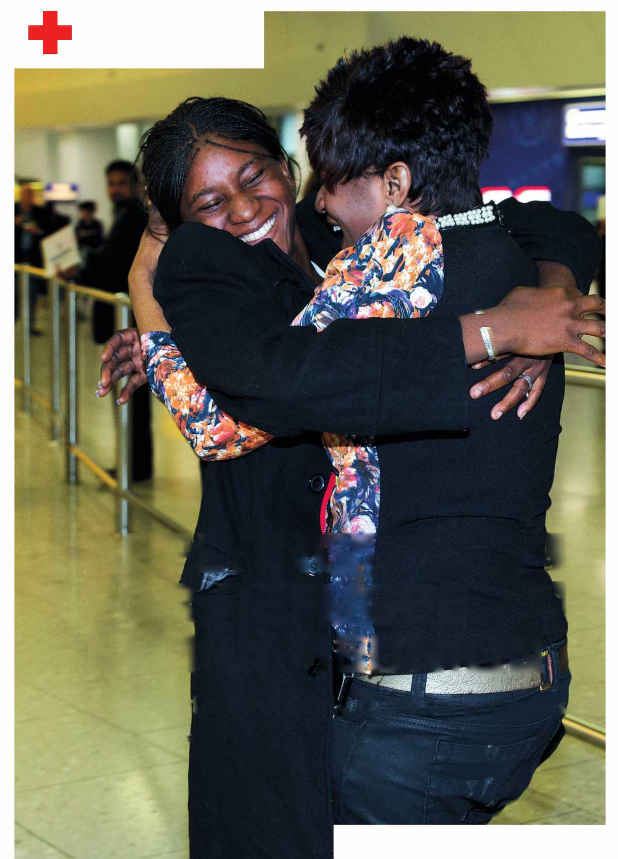

**British RedCross**

Refusing to ignore people in crisis

**APPLYING^ I FOR REFUGEE 1 FAMILY REUNION**

**A guide to the family reunion process**

Updated 27 June 2017

Acknowledgements

This guide would not have seen the light of day without the dedication and passion of our colleagues, Sarah Foster and Clare Tudor. The support and feedback of the family reunion project caseworkers Helen Mead, Joanne Hooper and Lilian Rose has been equally invaluable.

The legal professionals at Asylum Aid and Rochdale Law Centre, who have worked with the British Red Cross in supporting refugee family reunion applications, must also be thanked for sharing their knowledge and experience.

Last but not least, we would like to express our heartfelt gratitude to legal consultant Julian Bild for sharing his precious expertise and guidance on refugee family reunion.



Foreword

The British Red Cross recognises that refugee family reunion is a complex process - whether identifying and aggregating necessary documentation, planning trips to embassies across borders, or convincing the UK government that the people abroad applying for reunion really are family. We also recognise family reunion as a right entitled to individuals granted refugee or humanitarian protection status.

Until the Legal Aid Sentencing and Punishment of Offenders Act 2012, refugee family reunion applications were eligible for legal aid all over the UK. This enabled access to legal advisers who could support applications by deciphering requirements, identifying relevant documentation and supporting the submission of applications. Following the 2012 Act however, refugee family reunion was no longer eligible for legal aid in England and Wales and people were left to either make their own applications, or hire solicitors at great financial cost, in order to see their families again.

Because refugee family reunion is a complex process, and because the resources available to families to navigate such applications have diminished, we are seeking out fresh ways to ensure that families can reunite. We think a new application form and guidance will help, but maintain the view that legal support is also vital. We are conscious of the realities in England and Wales - in contrast to Scotland and Northern Ireland, where legal aid continues to support refugee family reunion applications.

This guide is another tool that will hopefully help some families prepare and submit their applications. We have designed the guide to help people who have no support or who are trying to better understand what the application process entails. Despite our efforts to ease the burden of applying, we maintain that the only durable solution is publicly funded legal support.

^^CO(Oloa)C»NN-<(JiUlLnin^N)MO<OK)(JimN)<OOOCON(JimUlUlUl

Contents

1. Introduction 5
   1. How to use this guide
   2. Feedback
   3. Disclaimer
2. Where can I get help? 
   1. Free legal advice and legal aid
   2. Additional information
3. Before you begin: understanding family reunion 
   1. Family reunion and the law
   2. The family reunion process
   3. Eligibility: am I allowed to bring my family to the UK?
4. Evidence gathering 
   1. What evidence do I need?
   2. Common issues and problems
   3. Presenting your evidence
   4. Witness statements
5. Applications and form filling 
   1. Applications: before you begin
   2. Making the applications
6. Making your application bundle 
   1. Next steps
   2. Creating a bundle
   3. Posting your documents
7. Preparing for, and attending the embassy appointment 
   1. Your family must
   2. What happens at the overseas mission / embassy?
   3. Changing or cancelling embassy appointments
   4. I have missed my embassy appointment
8. Decisions and outcomes 
   1. How will I know when a decision has been made?
   2. What happens if my visa(s) are approved?
   3. What happens if my family members' applications are rejected?

Glossary

1. Introduction

**This guide has been given to you because you have asked us about refugee family reunion. This guide will help you understand:**

1. Who is eligible for refugee family reunion.
2. How to make the application.
3. What evidence is required and how it should be organised.
4. How to use this guide

This guide has been written for refugees and their families, and can be used as an independent resource or to provide extra help during advice sessions. The guide should be read in sequence to make the best use of it. It is important to read the actual law and guidance (which is written by the Home Office) so that there will be no misinterpretations or misunderstandings - links have been provided to the relevant parts of the rules. If any issues addressed in this guide are unclear, or you require more specific help, we recommend you seek regulated advice. We have provided useful contact information for such advice at the back of this guide.

Where words are written **in bold**, you will find them in the glossary at the back of the guide

**Please note that this guide is a resource to help refugees understand the family reunion process. It should not be used by unqualified individuals to provide immigration advice on family reunion. Providing immigration advice if you are not qualified and not regulated is an offence under the Immigration and Asylum Act 1999.**

1. Feedback

We would very much appreciate feedback on this guide. Any comments, questions and suggestions can be sent to Vanessa Cowan [(vcowan@redcross.org.uk)](mailto:vcowan@redcross.org.uk)

1. Disclaimer

This guide has been written as a resource to help refugees and their families understand the family reunion process. We know that refugee family reunion is a complex process. At the British Red Cross, we are advocating for the process to be made simpler. However, in the meantime, we hope that this information will be useful to families who are making the application. While it is always preferable to obtain tailored legal advice to your particular circumstances, this guide is intended to help when it is not possible to obtain legal advice. Following this guide does not guarantee that your application will be successful. For this reason, we maintain that the only durable solution is publicly funded legal support.

This guide does not replace face-to-face advice. It is impossible to cover all aspects of this complicated area of immigration law in such a small guide, and as such only the key points are raised. Every case is different: it may be that some issues within a particular case are not covered in this guide, or issues covered in the guide are not relevant to an individual case. Flow charts and visual aids have been included in the hope that they may provide a clearer explanation of some points, but they are not a complete overview of the entire process. For cases not covered by this guide, it is always advisable to seek advice from a person or agency regulated by the Office of the Immigration Services Commissioner (OISC) or Law Society.

1. Where can I get help?

Always seek professional help if you can. However, if you cannot find legal assistance, this guide will help you navigate the process.

For legal representation it is important that you find an adviser who is regulated by the OISC or who is registered with the Law Society, and IAAS accredited. For a list of OISC-regulated advisors in your area, visit [www.oisc.gov.uk.](http://www.oisc.gov.uk/) To find a representative who is both registered with the Law Society and IAAS accredited, visit [www.lawsociety.org.uk.](http://www.lawsociety.org.uk/)

* 1. Free legal advice and legal aid

On 1 April 2013**,** significant changes to Legal Aid happened as a result of the Legal Aid Sentencing and Punishment of Offenders Act. As part of these changes, refugee family reunion was no longer eligible for free legal advice under legal aid in England and Wales. Recently at appeal, the court upheld that family reunion is not within scope of legal aid. As a result, it is no longer possible to obtain legal aid for family reunion applications or appeals in England and Wales. Generally, options for free legal advice are very limited. It may be possible to get some free legal advice from your local Law Centre or Citizens Advice Bureau. At appeal, it may be worth contacting the Bar Pro Bono Unit.

It is worth noting that the government has allocated some funds for legal advice in ‘exceptional cases' (**exceptional case funding**), which may include family reunion cases. It is possible to apply for exceptional case funding directly and the form can be found here: [https://www.gov.uk/legal-aid-apply-for-exceptional-case-funding.](https://www.gov.uk/legal-aid-apply-for-exceptional-case-funding)

For additional advice or signposting, speak with:

**>** Bar Pro Bono Unit - [http://www.barprobono.org.uk](http://www.barprobono.org.uk/)

**>** Citizens Advice Bureau - [http://www.citizensadvice.org.uk](http://www.citizensadvice.org.uk/)

**>** Free Representation Unit (FRU) - [http://www.thefru.org.uk](http://www.thefru.org.uk/)

**>** Law Centres Network - [http://www.lawcentres.org.uk](http://www.lawcentres.org.uk/)

**>** Refugee legal aid information - [http://www.refugeelegalaidinformation.org/united-](http://www.refugeelegalaidinformation.org/united-kingdom-pro-bono-directory) [kingdom-pro-bono-directory](http://www.refugeelegalaidinformation.org/united-kingdom-pro-bono-directory)

**>** Public Law Project -<http://www.publiclawproject.org.uk/exceptional-funding-project>

* 1. Additional information

The following websites will provide helpful information on family reunion and advice when you are going through the process.

UKVI website [www.gov.uk/government/organisations/uk-visas-and-immigration](http://www.gov.uk/government/organisations/uk-visas-and-immigration)

Family reunion information [www.gov.uk/settlement-refugee-or-humanitarian-protection/family-reunion](https://www.gov.uk/settlement-refugee-or-humanitarian-protection/family-reunion)

Information on where to apply [www.gov.uk/apply-uk-visa](https://www.gov.uk/apply-uk-visa)

Online applications, IHS reference number and booking embassy appointments [www.visa4uk.fco.gov.uk](http://www.visa4uk.fco.gov.uk/)

Appendix 4 application form [www.gov.uk/government/publications/application-for-uk-visa-family-joining-refugee-form- appendix-4-vaf4a](http://www.gov.uk/government/publications/application-for-uk-visa-family-joining-refugee-form-appendix-4-vaf4a)

Country-specific information on how to make settlement applications [www.gov.uk/find-a-visa-application-centre](https://www.gov.uk/find-a-visa-application-centre)

This often includes:

- a link to the corporate partner's website for the Visa Application Centre (VAC)

- information on how to make enquiries

- a guide to visa-processing time.

Information on visa processing [www.gov.uk/visa-processing-times](http://www.gov.uk/visa-processing-times)

Information on TB test requirements [www.gov.uk/tb-test-visa](http://www.gov.uk/tb-test-visa)

Information on making a subject access request [www.gov.uk/government/publications/requests-for-personal-data-uk-visas-and-immigration](http://www.gov.uk/government/publications/requests-for-personal-data-uk-visas-and-immigration)

**Commercial partner websites**

VFS Global [www.vfsglobal.com](http://www.vfsglobal.com)

TLS Contact <https://uk.tlscontact.com>

1. Before you begin: understanding family reunion

In this section we will cover:

**>** The rules around family reunion.

**>** The family reunion process.

**>** Eligibility criteria.

* 1. Family reunion and the law

Refugee family reunion represents just one of many types of visa: it is a right attached to being recognised as a refugee. Family reunion is a process by which refugees can be reunited with their immediate **pre-existing** or **pre-flight family**. In this process, the refugee in the UK becomes **the sponsor** and **the applicants** are the family members abroad who are making the application. There are some key differences between family reunion visas and other settlement visas, including the following:

**>** You do not need to pay an application fee.

**>** You do not need to meet any financial or accommodation requirements.

**>** Your family do not need to meet any English language requirements.

The rules that govern family reunion are found in the Immigration Rules, and are supplemented by Home Office guidance. You should try to read the relevant rules and guidance before you start your application. Some information on them can be found below.

Before applying for family reunion visas, you need to establish the following:

**>** You are eligible to bring your family to the UK (only people with certain immigration status in the UK are allowed to sponsor family reunion visas).

**>** Your family are eligible to join you in the UK (only certain family members can join you in the UK).

**>** You can prove with evidence that you meet all the requirements in the Immigration Rules.

This guide does not address applications which can be made based on Article 8 of the

European Convention on Human Rights - your right to a family life. Although relevant, human rights law is outside the scope of this guide. If you are seeking to rely on your right to family life in an application, it is recommended that you seek professional legal advice.

What are the Immigration Rules?

The **Immigration Rules** are written rules that state who can and cannot enter and stay and settle in the UK. It is important that you know which rule you are applying under, and whether you and your family are eligible for family reunion. There are rules and guidance covering every aspect of the application process. These rules (and the main body of the **UK law** relating to family reunion) can be found in **Part 11 of the Immigration Rules**.

**You can find the full version of the Immigration Rules here**: [www.gov.uk/government/collections/immigration-rules](http://www.gov.uk/government/collections/immigration-rules)

What else should I look at before starting?

The Home Office also issues **guidance** which must be followed by **Entry Clearance Officers (ECOs)**, the people who decide whether your family will be granted **VISAs.** It is a good idea to read the guidance before starting the application process.

**The guidance relating to family reunion can be found here:** [https://www.gov.uk/government/uploads/system/uploads/attachment data/file/541818/Famil](https://www.gov.uk/government/uploads/system/uploads/attachment_data/file/541818/Family_reunion_guidance_v2.pdf) [y reunion guidance v2.pdf](https://www.gov.uk/government/uploads/system/uploads/attachment_data/file/541818/Family_reunion_guidance_v2.pdf)

This guidance replaced the following instructions on the 29 July 2016:

* Family reunion Asylum Instruction (AI)
* Family reunion / leave in line interim AI
* Settlement (entry clearance) guidance (SET10)
  1. The family reunion process

A road map of the family reunion process is included below, which will hopefully clarify the main stages of making a family reunion application. Please be aware that this is a simplified process chart and there are no timescales included. In summary, family reunion applications tend to follow the pattern of:

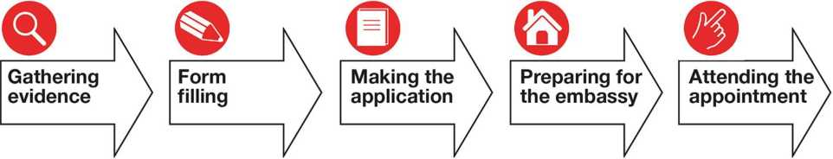

As the UK sponsor, your role will normally be more involved in evidence gathering and form­filling. However, it is important to remember that this is your family's application, so they need to be involved in the process as much as possible to avoid confusion or complications at the embassy. For this reason, we show the process as involving both you and your family from start to finish.

Family reunion road map

Sponsor in UK

Evidence Gathering

> Complete online application form for every family member ([www.visa4uk.fco.gov.uk](http://www.visa4uk.fco.gov.uk))

Do you need to write a statement or letter?

> Book appointment for your family to attend the VAC/embassy and register on the corporate partner website.

> Ask your family to send you photocopies of relevant documents. They keep the originals.

> Your family need to provide details of their address, their parents details, their travel history and passports.

> Complete Appendix

4 form for every family member.

Do your family need to , apply for passport? J

Do you need documents translated into English?

Family abroad

> Understand what evidence documents you need.

I

Check carefully that all names and D.O.B on the application forms match your family's details on their

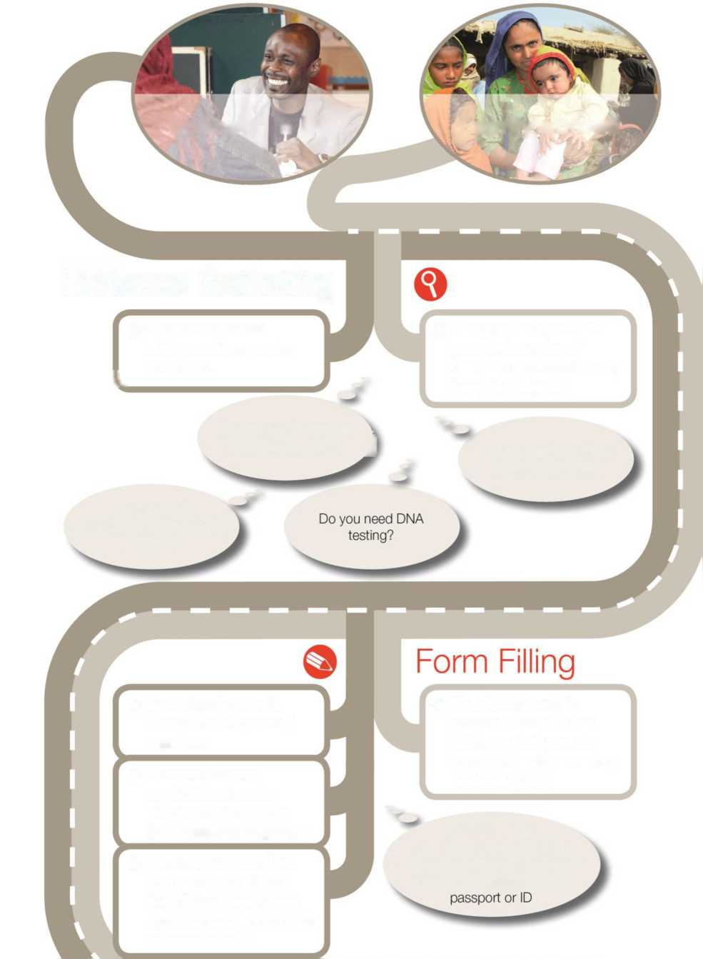

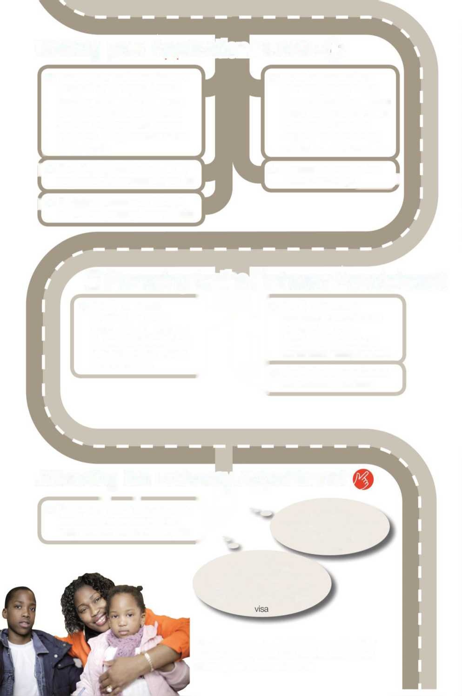

**You have now submitted your Family reunion applications. A decision can take up to three months.**

Making your Application Bundle O

> Print of your online application forms and your appointment booking details. Add this your completed Appendix 4 forms and the evidence documents you have. Put your cover letter i at the front.

[ > Send the bundle of documents to your family overseas by courier.

J > Register embassy appointment on VAC corporate partner website.

> Label the forms where your family need to sign them, check all translations have been included where documents are not in English, and photo copy your bundle of documents.

> Register for Immigration Health Surcharge.I

It

> Family sign the application forms where indicated.

> Family replace any photocopied documents with originals if they have them (eg marriage certificates, passports etc).

O Preparing for the Embassy Appointment

> Family may need to attend a TB test appointment and get a TB test certificate which they add to the bundle of documents.

Your family should not accept parts of the bundle back at this stage (eg photos)

Attending the Embassy Appointment

— “

> Your family bring the completed bundle to the embassy. They may be interviewed at this point.

)*

Ensure your family know that the person receiving their application is not the person making the decision on their

* 1. Eligibility: am I allowed to bring my family to the UK?

The sponsor (person in the UK)

The sponsor may apply under family reunion rules under the following conditions:

**>** They have been recognised in the UK as a refugee, and do not yet have British citizenship.

**>** They have been granted five years' humanitarian protection, and do not yet have British citizenship.

**>** They have come to the UK through the UNHCR's resettlement programs (for example: the Gateway Protection Programme, Mandate Refugee Programme or Syrian Vulnerable Persons Resettlement Scheme).

If you have been a refugee but then become a British Citizen, you will not be able to apply for refugee family reunion and instead will have to make an application under a different set of rules. There is a cost to these applications. If you are a refugee and considering becoming a British Citizen, it is advisable to wait until your family reunion application has been completed before starting the process.

**You cannot be a sponsor (in family reunion applications) if you are a British citizen, if you are a child (i.e. under 18 years old), if you came to the UK through family reunion yourself or if you were granted refugee status as the dependent of someone with refugee status.**

The applicants (family abroad)

**Only *pre-existing* or *pre-flight* families qualify for family reunion.** Pre-existing means family members, who were your family and who you were normally living with before you fled your own country (or the country where you were living). The list of eligible applicants below only applies if they are pre-existing family.

Family reunion normally takes place when family members are overseas: however; there are ways of applying for family members who are already in the UK. If your family members have arrived in the UK and you otherwise meet the criteria for family reunion, you may be able to make an in-country application.

Who can I bring to the UK through family reunion?

You will only be allowed to bring close family members who formed part of your pre-flight family unit to join you in the UK. This is limited to:

**>** A spouse (wife or husband), A civil partner or an unmarried / same sex partner, providing that you and your partner had been together for two years or more before you fled your own country to seek asylum.

**>** A child under the age of 18 who is **not leading an independent life**, is still dependent on the family, is unmarried, is not in a civil partnership and has not formed their own separate family.

**>** An adopted child if you have an adoption order and that it was granted by the administrative authority or court in that country and that it was issued in the country where the child is from or is living.

**>** A child who had been conceived but was born after you left to seek asylum.

**>** Step-children who are under the age of 18 and who were part of your family unit before you fled to seek asylum in the UK. This only applies if the child's biological mother / father is dead.

Clearly, not all family members can join you in the UK. Bringing family members outside of the rules above is very difficult in a family reunion application. Instead, you may wish to consider bringing family members on another type of visa. For example: they may also be able to apply under other provisions of the Immigration Rules (e.g. Rule 297 or 319X or under Appendix FM).

If you cannot meet the requirement of the family reunion rules, you should seek legal advice about alternative options that may be available to you**.**

Definition of spouse/ civil partner / unmarried partner

The requirements for entry clearance or leave to remain as a spouse, civil partner or unmarried partners for the purpose of family reunion are set out in paragraph 352A of the Immigration Rules. You must provide evidence, to the required standard of proof, that all the following criteria are met:

* You and your partner have a valid marriage or civil partnership
* You have met each other
* the evidence produced establishes that the relationship between you and your partner genuine
* each of the parties intends to live together permanently with the other and that the relationship is subsisting

If you are not married or in a civil partnership with your partner you must show that:

* You have met each other
* You have been living together in a relationship akin to marriage or a civil partnership which has subsisted for 2 years or more
* that the evidence you provide establishes that the relationship between you and your partner is genuine
* that you intend to live together permanently and that your relationship is subsisting

Polygamous marriages

If you are in a polygamous or polyamorous marriage (you have more than one wife or husband still alive) it is not possible for more than one of your spouses to apply for refugee family reunion under the rules. If you are making an application for one of your spouses and you can only do this if none of your other wives/husbands are or have been, at any time since your marriage, in the UK, or granted entry clearance to come to the UK as your spouse.

Definition of a Child

The requirements for entry clearance or leave to remain as a child for the purpose of family reunion are set out in paragraphs 352D of the Immigration Rules. You must show that:

* You, the sponsor, are the child's parent
* the child is under the age of 18 at the time of the application - where a child reaches the age of 18 after such an application has been lodged, but before it has been decided, the caseworker must consider the applicant's eligibility under paragraph 352D of the Immigration Rules as if the applicant was still under 18
* the child is not leading an independent life
* the child is not married, in a civil partnership or formed an independent family unit

Step parents are unable to sponsor step-children under the rules unless the child's biological parent has died and you were married to the other biological parent of that child. Eg. You are the step-mother of a child and are married to the child's father, and the biological mother has passed away. In these circumstances, provided you can show a death certificate, you would qualify as a “parent” under the rules.

Adopted children

If, before you fled your country, you adopted a child you must be able to demonstrate that they hold an adoption order, and that it was granted either by the administrative authority in the third country, or by a court which has the legal power to decide such applications. The adoption order should have been issued in the child's country of origin, or where the child is living. Your adoption order must be recognised as valid for the purposes of UK law.

De facto Adopted children

De facto adopted children are dependent children who have become part of your family through circumstance, but who were never formally adopted by you or your partner. It is more or less impossible for de facto adopted children to meet the requirements of the immigration rules as they must have lived with their sponsor for a length of time immediately preceding the application for entry clearance - usually this is impossible in refugee circumstances. With sufficient evidence it may be possible to succeed in making an application outside the rules.

Applications outside the rules - Exceptional and compassionate factors

Occasionally, it is possible that applicants who are not pre-existing family members, or who do not fall into the ‘eligible' applicant's category, may be able to come to the UK because to refuse their application would result in unjustifiably harsh consequences for the applicant or their family and would therefore breach their ECHR Article 8 right to respect for their private and family life.

The Home Office guidance on family reunion states that; *”Where an application does not meet the requirements of the Immigration Rules, caseworkers must consider the family exceptional circumstances guidance or whether there are any compassionate factors which may warrant a grant of leave outside the rules.”*

The Applicant will have to demonstrate as part of their application what the exceptional circumstances or compassionate factors are in their case. The Home Office guidance is clear that;

“*Each case must be decided on its individual merits. Entry clearance or a grant of leave outside the Immigration Rules is likely to be appropriate only rarely and consideration should be given to interviewing both the applicant and sponsor where further information is needed to make an informed decision.”*

An example (given in the Home Office guidance) of circumstances which may be considered exceptional and compassionate could be where an applicant who cannot qualify to join parents under the rules because they are over 18 but all the following apply:

* their immediate family, including siblings under 18 qualify for family reunion and intend to travel, or have already travelled, to the UK
* they would be left alone in a conflict zone or dangerous situation
* they are dependent on immediate family in the country of origin and are not leading an independent life and there are no other relatives to turn to and would therefore have no means of support and would likely become destitute on their own

Another example is when an unmarried partner meets all the requirements except the condition of living together and it can be shown that if they had lived together it would have put them in danger.



4. Evidence gathering

There is no specific list of evidence which needs to be produced; however you will need to prove to the Home Office that you and your family, the applicants, meet the criteria laid out in the Immigration Rules.

The evidence you give must establish that the relationship between you and the applicant exists and that it is genuine. It must also establish that your relationship existed prior to you having fled your country to seek asylum in the UK, and that you and your family intend to live together in the UK. The Home Office guidance acknowledges that applicants and sponsors in family reunion cases may not be able to provide the level of evidence that would be required for other applications under the Immigration Rules, due to the nature of refugee journeys. However it is up to the applicant to provide a plausible explanation for the absence or lack of any evidence and to establish that they are in a relationship or related as claimed to you.

The Entry Clearance Officers will make their initial decision on the papers you and your family give to them, so it is important that you send all the necessary evidence and explain any missing documents in a short statement.

Remember to involve your family abroad in evidence gathering: you may not be able to provide some documents that perhaps they can (such as photos or itemised telephone records).

1. What evidence do I need?

You should include as many relevant documents to support your application as you can. **Please note that any documents not written in English need to have a certified translation**. Below is a list of the evidence you may need to provide.

This is not an exhaustive list, and it is not expected that an applicant would have all of the following. However, generally speaking the more evidence you can give, the better. This of course assumes that the evidence you are giving actually does prove what you think it does. For example: itemised telephone records with no telephone owner details may not be very useful. Similarly, records showing only a few very short phone calls each month will not prove that you are in daily contact with your family.

If you are not sending original documents (for example, your biometric residence permit or ID card) these copies should be **certified** if possible. Certification means that someone will say that the photocopied document you are providing is a true copy of the original. For information on how to get a document certified in the UK see [https://www.gov.uk/certifying-a- document](https://www.gov.uk/certifying-a-document)

The Home Office guidance states that

*“Applicants could include any number of documents to support their claim that they are related as claimed, this could be:*

* *marriage certificates*
* *traditional marriage ceremony documents*
* *documents relating to accommodation or joint purchases*
* *DNA tests (at the applicant's expense and from an organisation accredited by the Ministry of Justice - HM Courts and Tribunal Service)*
* *birth certificates*
* *adoption orders*
* *original letter from UKVI or Immigration Enforcement (IE) confirming the sponsor has leave and status as claimed in the UK*
* *family photographs*
* *wedding photographs*
* *wedding invitations*
* *witness statements (from the sponsor and applicant, wedding guests, family members, or person who conducted the ceremony)*
* *communication records (telephone records, emails and letters for the period they have been apart, or social media messages)*
* *any other evidence indicating the relationship is as claimed”*

Gathering your (the sponsor's) evidence for family reunion applications

Proof that you have refugee status (or humanitarian protection/ILR following refugee status)

**>** Refugee status / humanitarian protection status document / Gateway protection status documents or biometric residence permit. If you have Indefinite Leave to Remain (ILR), proof of your previous refugee status and current status.

**>** Travel document / certificate of travel.

**>** The letter you received when your asylum was granted, or your appeal determination (if you were granted asylum after an appeal).

Proof that you have a pre-existing relationship

If you have named your family in your asylum case the Home Office guidance says that; *“Caseworkers must take into account any other evidence previously available to the Home Office as part of any other application. For example, evidence submitted as part of the asylum claim (statement of evidence form (SEF), witness statements, asylum interview or evidence from any appeal hearing). The fact that family members have been mentioned in the asylum claim is a strong indication that they formed part of the pre-flight family unit.”*

**>** A copy of your asylum screening interview notes and substantive interview notes, if you mentioned your family members in the interviews.

**>** Witness statements provided as part of your asylum case or appeal hearing

**>** It is helpful if you can write a short statement, which outlines who is applying to join you and your relationship with them. **(See the section on writing a statement below**.**)**

Applicant's documents (your family's evidence)

General documents that all family members need

It is important to check that the spelling of all names and dates of birth in all your family's documents (and any translations) match the spellings in your interview documents. If there are any differences, you will need to write a brief explanation in your statement explaining why they are different:

***Example 1****: On your child's birth certificate and passport, their name is spelt Rebecca. But in your asylum interview with the Home Office, the name you gave was spelled as ‘Rebekah' in the record.*

***Example 2****: At your asylum interview, you told the Home Office that your husband's date of birth was 01.01.1978. But when you see his passport, it gives his date of birth as 01.01.1980.*

**>** Passport or travel document for **all** family members who will be travelling. **Please note that if any applicants do not have passports, they should apply for them immediately.**

**>** If it is absolutely not possible to obtain a passport and you can show reasons why this might be the case you may be able to ask for an **EU Uniform Format Form** (known as a **UFF**), which allows one-way travel. An example of when this may be necessary is if your family have also had to flee their country of origin because of persecution and cannot approach the embassy for travel documents.

**>** Original photographic identification documents or any proof of identity. This is really necessary if your family member(s) do not have passports or travel documents. The Home Office needs to be sure that your family are who they say they are.

Documents needed if your husband, wife or unmarried partners want to apply

Proof of pre-existing relationship / marriage / civil partnership.

**>** If you are married or in a civil partnership, you need to provide an original marriage certificate or civil partnership certificate. This should show that your marriage took place **before** you left your country to seek asylum and is considered a ‘**valid' marriage**. The marriage certificate will only be considered valid if the marriage took place according to the rules of the country in which it occurred. If you are concerned that your marriage may not be considered valid, consult a professional legal advisor before continuing with your application.

**>** Divorce certificate(s) if your current marriage / civil partnership is not your first, and the country in which you married your current applying spouse does not recognise polygamous marriages.

**>** If you remarried after being widowed, the death certificate of your previous spouse.

**>** If you are an unmarried partner, you will need to show that you **have been in a relationship for two years** and that you have lived together with your partner. Do you have shared bills, photos or other proof that you were partners for two years or longer?

**>** Photos or videos taken at the wedding / civil ceremony. (Videos can be sent and have been known to be accepted on a CD-ROM but this could vary between VACs.)

**> Witness statements** from people who attended your wedding or civil partnership ceremony.

**>** Family photos of you and your spouse / partner together before you left to claim asylum.

Proof that you are still in a relationship

**>** Evidence that your husband, wife or partner is still in contact with you since you left your country (for example: via Viber, Skype, Tango, WhatsApp, Facebook messages, email, phone cards, itemised telephone bills or online call records). For guidance on how to do get this evidence, please see the section below: ‘I don't know how to obtain records of contact'.

**>** If you lost contact for some time, evidence of how you regained contact with each other. This may prove helpful if it has been some time since you were granted status in the UK, but you could not make an application earlier because you didn't know the location of your partner.

**>** Money transfer receipts if you are sending money to support your spouse / partner, or they are sending money to you.

**>** Letters and greetings cards.

**>** If you have been able to visit your husband, wife or partner, it is helpful to provide evidence of such visits. This could include: visa stamps, photos of you both together, and proof of travel (airplane tickets, rail tickets etc).

Documents needed for children who are applying

Proof that the child is your child (or the child of your wife / husband or partner)

**>** Birth certificates for every child: this is to show that they are your child and so **must** name you as their mother or father on the birth certificate. If you are a step-parent, the birth certificate is still useful to show the child's relationship to their biological mother or father (your wife, husband or partner). This will also prove that the child is aged under 18, which is another requirement of the rules.

**>** If the child is your step-child, you will need the death certificate of their biological parent.

**>** If the child has a parent who is not planning to join with you in the UK, you will need their written consent for the child to join you. You may also need legal advice about the issue of **sole responsibility**.

**>** Adoption certificate / court declaration if your children are adopted.

**>** Family book / UNHCR family registration book.

Proof that the child is not leading an independent life, married, or has formed their own separate family

**>** Evidence that you have been maintaining or looking after the child (for example: proof of child maintenance payments or bill payments to guardians, overseas schools etc).

* Proof of parental instruction - such as messages sent to guardians relating to the care of the child.
* Witness statement from the child (if old enough).
* Witness statement or letter from the guardian (the person looking after the child at their current location) giving details of how you maintain responsibility for the child and why they believe the child would be better off with you in the UK.

**>** Records of contact with the child or other evidence that you are continuing life as a family despite the fact you are currently separated.

Proof that you were a family unit before the sponsor left to claim asylum

**>** Family photos and videos of you and the child together.

**>** Evidence that you were responsible for the child before you left them (for example: proof that you registered the child at a doctors' surgery, paid their school fees or registered them at school).

**>** Witness statement from you, the guardian, other family members or the child if they are old enough.

**Note**: Proving a subsisting relationship with children is not a requirement of the rules, but the ECO may be concerned if it appears there has been no relationship between you and the child at all since your separation.

Resettlement Scheme Evidence

If you arrived to the UK on the Syrian Vulnerable Person Resettlement (VPR) Programme, Gateway Protection Programme or Mandate Refugee Programme you must satisfy the Entry Clearance officer that you declared your family member on your resettlement application form. The Home Office acknowledge that “*there may be legitimate reasons why the sponsor did not mention a dependant at an earlier stage and any explanation provided must be carefully considered”*. It is important to be aware that the ECO may refuse your application if you cannot provide a suitable explanation of why you failed to mention your family.

**If you came as a dependent of your parent through a resettlement programme, your parent may need to seek independent legal advice as you will, essentially, be arguing against what they stated as the truth in their interview leading to their grant of refugee status in the UK. This could potentially lead to a review of their refugee status (see revocation of refugee status).**

You will most likely need to undertake a Subject Access Request to UKVI in order to obtain your interview conducted abroad.

Supporting Document Checklist

|  |  |  |  |
| --- | --- | --- | --- |
| **Rule** | **Evidence needed** | **Document ready?** | **If not available remember to provide an explanation in a statement or cover letter** |
| Proof of Refugee Status | Your Biometric Residence Permit |  |  |
| Asylum determination letter |  |  |
| Your travel Document |  |  |
| Your Gateway / Mandate / SVP Resettlement letter |  |  |
| Family members Proof of Identity | Your family members' passports |  |  |
| UNHCR registration documents / attestation |  |  |
| School ID card or letter |  |  |
| National ID card |  |  |
| Asylum status registration documents if family have claimed asylum in another country |  |  |
| Proof of relationship | Marriage certificate |  |  |
| Divorce Certificate (if previously married) |  |  |
| Death certificate (if widowed or step-parent) |  |  |
| DNA test |  |  |
| Birth Certificates |  |  |
| Adoption Orders |  |  |
| Pre-flight relationship (NB some of the above documents and certificates would also indicate a pre-flight relationship) | Sponsor's asylum screening interview, SEF interview, asylum statements, court decision etc naming family members |  |  |
| Documents relating to cohabitation, accommodation or joint purchases, joint bank accounts, joint utility bills etc |  |  |
| Family photographs taken pre-flight |  |  |
| Wedding photographs, invitations, video etc. |  |  |
| witness statements (from the sponsor and applicant, wedding guests, family members, or person who conducted the ceremony) |  |  |
| Your relationship is subsisting | emails and letters for the period you have been apart |  |  |
| Social media messages / communication for the time you have been apart |  |  |
| Phone cards / itemised phone bills |  |  |
| Evidence you have visited your family |  |  |

1. Common issues and problems

I am married but cannot provide a marriage certificate

In such a case, it will be very helpful to show that you mentioned your partner / spouse in your application for asylum - so providing a copy of the asylum screening interview or substantive interview where your husband, wife or partner are mentioned is important. If you do not have these documents, you can apply for them through a **subject access request** (information on how to do this is discussed below).

It would be useful to provide photos of your wedding if you have them. And it's also important that both you and your partner address the reasons for not having a marriage certificate by each writing a witness statement. If possible, try to obtain a letter from the marriage or wedding venue stating when you were married there, and witness statements from people who attended the wedding.

Additionally, if you have children with your wife or husband, it may be useful for you and the children to have a DNA test to provide evidence of your pre-existing relationship with your partner.

I am not married and cannot provide proof that I have been in a relationship with my partner for over two years, and that we lived together

Both you and your partner will need to write statements discussing your relationship and for how long you have lived together. It will also be necessary to rely on witness statements in this case. For example: you may have had neighbours, friends or family members who knew about your living arrangements or a landlord who you paid rent to. And if you have children with your unmarried partner, are you both named as the child's parents on the birth certificate? (This could help to prove you have been in a relationship.) Additionally, you will likely have mentioned your partner in your screening and/or substantive interviews with the Home Office during your asylum claim.

I cannot provide birth certificates

If these are not available, you will need to explain why there are no birth certificates in a witness statement. In order to prove that you are related to the child as you claim to be, it may be necessary to undertake a DNA test. However, you could rely on other evidence such as family photos.

DNA tests can be conducted under the government scheme or on a private basis. The government scheme (see Entry Clearance Guidance SET 7.11) means that the government/embassy will occasionally offer to test free of charge, but only for first-time family reunion applications as a last resort when every other means of verifying the relationship has been exhausted, and where ‘related as claimed' would be the sole reason for refusal.

If you decide to undertake a DNA tests privately (i.e. you pay) for either initial application or for appeal, it is important you carefully read the guidance on private DNA tests and check that the DNA testing provider you are using is recognised by Home Office. These tests can be very expensive.

I cannot provide ID

It is very important that anyone who is making an application can prove they are who they claim to be. Family members must have ID in order to make an application for family reunion. This can be an asylum / refugee status document, national ID card, birth certificate, passport, driving licence, UNHCR registration or attestation, school or college ID card etc. If you do not have ID of any kind, it will be necessary to obtain this before proceeding.

My family cannot provide passports

If your family member(s) cannot obtain a valid passport for reasons outside their control, this does not prevent them from making an application for family reunion. Sometimes, it is simply not possible for applicants to obtain them. However, your family should try to obtain passports, particularly if they are nationals in their own country (for example: Ethiopians in Ethiopia).

If they are unsuccessful, you will need to show that they have at least tried to apply for passports - and may need to add relevant emails / letters / forms / correspondence to your evidence bundle with their national embassy. Identification documents (in some form) will still be required for your family members, to prove that they are who they state they are. You can then ask the embassy, in your covering letter, to accept the family reunion application and issue the visa using a one-way travel document called a Uniform Format Form (UFF).

I have not mentioned my family in my asylum claim: what do I do?

Naming your family in your asylum claim is one way of evidencing that you had a pre­existing family when you came to the UK and claimed asylum. If you did not mention your family in your asylum claim, you will need to include a cover letter or statement explaining the omission and giving clear reasons for it.

Not mentioning your family in your asylum claim is not in itself grounds for refusing your family's application, but you will have to find other ways to evidence that you were a family together before you came to the UK. Perhaps you have photos or other documents (bank statements, house deeds, school or GP letters, registers from your local community centre / church / mosque) that show you lived together as a family before you left your country to claim asylum. Or perhaps you can obtain a family certificate from your local authority to show that you all lived together in one house?

What if I have lived in the UK for some time before arranging this application?

Family reunion applications are not time-limited in themselves, provided you meet the eligibility criteria. If you have had refugee status / humanitarian protection for a few years before starting to submit the application, the Entry Clearance Officer will probably want you to explain in your cover letter or witness statement why you did not begin the family reunion process earlier. The ECO cannot refuse you only on the basis that you waited to make the application, but they may doubt whether your relationship is genuine and subsisting.

I don't know how to obtain my records of contact.

**It is important to show you have remained in contact with your family since separation. Getting records of contact from applications such as Viber and WhatsApp can take time, and will often require you to backup files and export them via email. You can also take screenshots of your phone messages.**

Viber

Visit [http://support.viber.com/customer/portal/articles/1334452-create-a-backup-file-of-your-](http://support.viber.com/customer/portal/articles/1334452-create-a-backup-file-of-your-messages%23.U0-pNxBdXTp) [messages#.U0-pNxBdXTp](http://support.viber.com/customer/portal/articles/1334452-create-a-backup-file-of-your-messages%23.U0-pNxBdXTp)

If you would like to create a backup file for your messages, you can do so easily by following these steps:

1. Open **Viber**.
2. Select **More options**.
3. Select **Settings**.
4. Select **Calls and messages**.
5. Select **Email message history**.
6. Once the backup file is created, select the application through which you would like to email it, then send it to yourself or any other email.

WhatsApp

Retrieving messages from WhatsApp depends on which phone you use. For information on how to backup or export your WhatsApp, please visit:

whatsapp.com > FAQ > General > How do I back up or export my messages? <http://www.whatsapp.com/faq/general/23753886>

Skype

Log in to a computer and click View > Recent history. You should then be able to select your family members' contact history and scroll through their messages over the past few months.

You can print these by taking a screen print (press Control and Print Screen on your keyboard) and pasting the print screen image into a word document. If you only use Skype on your phone, you may need to take screenshots of the relevant Skype messages then email the saved pictures so you can either print them, or save them on a CD-ROM or USB stick.

Facebook

On a computer, you can open privately sent messages and conversations with particular people in a separate tab, then print them (click file > print) or copy and paste them to a word file. On your phone, you may need to take screenshots of the Facebook messages and email the saved pictures so that you can print them or save them on a CD-ROM or USB stick.

Screenshots:

In some cases, it may be easier to take screenshots on your phone of conversations, texts, messages and call history with particular family members. These are then saved as photos on your phone in the photo gallery. To take screenshots on most phones you need to

1. Navigate to the screen you want to capture.
2. Press and hold down the round button at the centre bottom of your phone, or the home icon (usually in the middle) on the bottom of your phone. At the same time, you will need to press the camera or sleep button located at the side or top of your phone.
3. Press and release the camera or sleep button, and you will hear a camera-like shutter sound
4. Release the home / camera button.
5. The screenshot will be automatically saved in your photo album or photo gallery, and can be emailed to yourself from your phone to print. Alternatively you can email and copy the screen shots to a USB stick or CD-ROM.

Phone records

Getting records of contact may depend on the contract you have with your mobile phone provider. If you have a contract phone, it is normally easier to get your phone records. Difficulties generally arise if you are using a pay as you go phone, so we deal more with these here.

As a general start point, contact the customer service team of your phone provider and ask how you can obtain records of your call history.

Phone cards are often produced as evidence of contact, but they will not be enough on their own since you cannot prove they have been used to speak with your family. It is a good idea to hold on to any phone cards or vouchers that you do buy, but it is not ideal to rely only on phone cards as evidence of contact You should try to obtain your phone records as well.

Don't forget that your family abroad may also be able to get hold of itemised records showing when they have been calling you.

Lycamobile

Lycamobile gives you the option to either print your own records, or send off for them. However, you must **register** your sim before you can pursue either of these options.

You can register your sim card by visiting [www.lycamobile.co.uk](http://www.lycamobile.co.uk/) and clicking on ‘register your sim', Alternatively, you can call 332 if you have a Lycamobile phone, or 0207 132 0322**.**

**You will then receive a text message with a code that will allow you to access your online phone records over the past six months.**

**Next steps: 1.** Visit Lycamobile.co.uk **2.** Click on MyLycamobile **3.** Enter both your Lycamobile number and the code that has been sent to you (which is case sensitive).

Take a screen print (hold Ctrl and Print Screen button on your keyboard) of the page that shows both the telephone number and your name, to demonstrate that this is indeed your Lycamobile account.

Click on ‘My call history' and you will have the option to view the phone records for the last six months. To print, select the month you want from the drop down menu, wait for it to load and open as a PDF. You can then print the PDF file.

For each month you view, take a screen print or print the webpage by clicking on ‘file > print'. This is because the PDF will not feature your telephone details, so it may be difficult to show that the records belong to your number).

Alternatively, register your sim card and obtain your records by posting a letter to Lyca mobile. State exactly what you want, the reasons for the request, and include your name, telephone number and address. Also enclose a postal order for £7.50. You cannot send cash.

Lebara

As with Lycamobile, register your sim card and sign up to MyLebara. You will then be provided with a log-in code that gives you access to your account online. There is an online video that shows you how to view your call and data history: [www.lebara.co.uk/view/content/pl_helparticle?portId=4&catId=4&articleId=1071](http://www.lebara.co.uk/view/content/pl_helparticle?portId=4&catId=4&articleId=1071)

**Getting extra information**

1. If you require your call history information between 30 days and 12 months, you will need to be registered to MyLebara and will be charged a £10 fee (payable by cheque).
2. You will receive your call history within 40 calendar days of Lebara receiving the cheque.
3. You will also need to include a Subject Access Request Form (SAR), which can be printed from MyLebara's website.
4. Once you have completed the SAR, send it along with your £10 cheque to: LEBARA LIMITED, Legal Department, 2nd Floor, 25 Copthall Avenue, London EC2R 7BP

Three

If you have a Three mobile contract, you can access your telephone records online. To do this you just need to log in to your My3 Account: [www.three.co.uk/My3Account/Login](https://www.three.co.uk/My3Account/Login)

If you have not already registered with them, you can do so here: [www.three.co.uk/My3Account/Register](http://www.three.co.uk/My3Account/Register)

You will need the last six numbers of your sim card to do this. Look on the right-hand side of the registration screen for instructions on how to find these on your phone.

When you log in to your account, click on ‘Bills'. At the bottom of the screen you will see a list of your telephone bills for each month. Click on the printer icon next to each of them to get a PDF document of your bill, which you can then print out for your application.

If you are on a pay as you go contract with Three, you can only request your telephone records for the months since you registered the sim card - so it is a good idea to register your sim card as soon as possible. You can do this by calling 0800 358 4948.

To get your call records, you must fill out a Three Mobile Subject Access Request form. You should send this to the address on the form with:

1. Proof of your identity (e.g. a photocopy of your immigration status document, biometric residence permit or travel document).
2. Proof of your address (e.g. a current council tax, gas or electricity bill showing your address).
3. A cheque or postal order for £10 made payable to Hutchison 3G UK Ltd.

How do I make a subject access request to UK Visas and Immigration (UKVI), or the Home Office?

If you need to ask the UKVI for documents, you do this through a subject access request. Information on how to make the request can be found here:

[https://www.gov.uk/government/publications/requests-for-personal-data-uk-visas-and- immigration](https://www.gov.uk/government/publications/requests-for-personal-data-uk-visas-and-immigration)

You complete the relevant form (if you are requesting your own documents, complete form A) giving details of what information and / or documents you require. Post the form to the given address, along with a cheque or postal order for £10 and a photocopy of your ID.

Think about where your evidence comes from and whether it is the best evidence you can find

In your application, anything you say or any documents you rely on can be checked by the Home Office. Always try to provide the best evidence that is available, and if it is not available explain why in a witness statement.

General grounds for refusal

As part of a family reunion application it is important that you and your family provide supporting evidence to establish their identity and evidence that they are related to their sponsor as claimed. If you provide false documents your family's application will be refused.

If false representations have been made or false documents or information is submitted (whether or not material to the application, and whether or not to your or your family's knowledge), or material facts have not been disclosed, in relation to the application or in order to obtain documents from the Secretary of State or a third party required in support of the application, your family's visa application will be refused.

**Reliance on fake documents or false information will damage your application. It can also lead to prosecution, potential revocation of your refugee status, removal from the UK and up to a ten-year ban on you returning, and a ban on your family re-applying. It is always better to provide a reason why a particular document is absent, rather than submitting documentation that is not genuine or stating something that you know to be untrue.**

This does not just apply to providing false documents but includes not disclosing any previous criminal activities, arrests, or warrants for arrest.

If your family member has previously been in the UK, and has previously been deported, overstayed or otherwise has a poor immigration record with the home office they may be refused depending on how long ago they were deported or how long they overstayed. Your family will also be refused if they have been in the UK before and have a debt with the NHS of over £500.

Revocation of the sponsor's refugee or humanitarian protection status

It is important to remember that when a family reunion application is made, the information submitted will be checked against any information provided by you as part of your original asylum claim or any subsequent application for indefinite leave or settlement that you have made. Where information given in the family reunion application gives rise to evidence of deception by you this could lead to a review of your entitlement to refugee status or humanitarian protection in the UK. The Home office acknowledge that your family may not always know the full details of the sponsor's asylum claim due to, for example, security reasons, however you may have to explain any irregularities.

This could be, if, for example, you have claimed asylum saying you are a Syrian national however in your family reunion application your documents all state that you are from another country.

**If you are in doubt about the general grounds for refusal or if you are concerned about issues which may trigger a review of your refugee status, seek legal advice from a solicitor or qualified immigration advisor.**

1. Presenting your evidence

It is very important to make it as easy as you can for the Entry Clearance Officer to know exactly what is in your evidence bundle, and why. Try to include a short cover letter for each application, which lists the evidence and documents you are providing and explains why you are providing them. A sample cover letter is provided below.

**Make sure you can provide original documents to the Entry Clearance Officer wherever possible.** If you cannot provide originals (for example: your UK biometric residence permit) try to enclose a certified photocopy - you can ask a solicitor to stamp and sign the photocopy. If you cannot get the photocopy of the document certified, always provide a written explanation of why the original is not available.

Sample cover letter

YOUR NAME AND

ADDRESS Entry Clearance Officer [EMBASSY ADDRESS]

DATE

Dear Sir/Madam

*Applicants: (Full name, date of birth, nationality)*

*Application reference number: GWF*

*IHS reference number: IHS*

*Sponsor: (Your name, date of birth, nationality)*

**Re: Application for refugee family reunion**

This is a refugee family reunion application made under part 11 of the Immigration Rules. The applicant(s) are applying for leave to enter and remain in the UK in order to join the sponsor, [INSERT NAME], who has been granted refugee status in the UK.

Please find below an index of the specific items of evidence enclosed with this application:

1. Completed VAF4A online application form for applicant [ insert name]
2. Completed Appendix 4 form for applicant [insert name]
3. Copy of the sponsor's, [insert name]'s biometric residence permit / status document
4. Witness statement of the sponsor [ insert name]
5. Birth certificate of the applicant and translation

Etc...[CONTINUE TO LIST ALL EVIDENCE THAT YOU ARE PROVIDING]

Furthermore, I respectfully advise that refusing my / our application for refugee family reunion would be a breach of our right to private and family life under Article 8 of the European Convention of Human Rights, 1998.

If you have any questions about the documents provided or the application, please contact me on [INSERT NAME AND CONTACT DETAILS].

Sincerely, [SIGN LETTER]

1. Witness statements

What are witness statements and when do I need them?

Witness statements are very helpful in explaining and supporting your application. You may have submitted a witness statement as part of your asylum application. They can be used to explain missing evidence, reasons for delay in applications, and any differences between information given during your asylum claim and that provided for the family reunion application.

It is also sometimes helpful for someone else to write a witness statement if they are able to confirm that what you are saying is true. If you are missing evidence, you may need to consider getting witness statements from some of the following people (depending on which particular evidence is missing):

***J*** Your partner / spouse.

***J*** Your children (if they are old enough).

***J*** The guardian of your children, if this is not your partner / spouse.

***J*** The other parent of your child, if that parent is not applying to join you in the UK.

***J*** Other friends and family members in the UK or abroad who can talk about your family relationships.

***J*** Religious leaders involved in your marriage ceremony and witnesses to a marriage ceremony.

***J*** People who have been involved in re-establishing contact with your family members after separation, or who have helped maintain such contact by delivering parcels, letters etc.

**Any witness statement needs to categorically state that what has been written is true and correct to the best of the author's knowledge. It should also be signed and dated. If someone's signature is hard to read, also print the name next to the signature.**

Writing your own witness statement

It is always best to try and get legal help when writing a witness statement, which can be used by a sponsor in support of an application or refugee family reunion. (Please note: the following example includes a list of useful information to include, but every case is different and you may not need to cover every point mentioned below.)

When you are finished with your statement, make sure that you read it over and are satisfied with the content before you sign and date it. You need to send the original statement as part of your bundle of evidence. You can write the statement in your own language, but you must then organise a certified translation. If you write the statement in English with the help of an interpreter or translator, you must ask the interpreter / translator to sign and date the statement as well.

Sample witness statement

1. *[full name], a (Sudanese/ Eritrean/ Pakistani etc...) national, born [date of birth], of [current address], make this statement in support of my [husband's / wife's / partner's / child's / children's] application for refugee family reunion with me in the UK.*

**>** The names, dates of birth and family relationship to the sponsor of the applicants seeking family reunion.

**>** Where a partner application is being made, some information on how you met and formed your relationship. (For example: I met my wife in February 2009. We were introduced at a family gathering.)

**>** Details of marriage / civil partnership / co-habitation. (For example: I married my wife on 21 October, 2009. We lived together at our home [address] from the date of our marriage until I was forced to flee.)

**>** Details of children, including names and dates of birth.

**>** Did you live together as a family unit in your country? If so, for how long? If not, why were you separated?

**>** Information about how you became separated from your family and how / whether you were able to stay in contact during your separation.

**>** A brief outline of your reasons for leaving your country and a summary of your immigration history. (For example: I left Sudan in June 2012 and arrived in the UK on 1 July, 2012. I applied for asylum on arrival and was granted status as a refugee on 1 November, 2012.)

**>** When and how did you regain contact with your family after arriving in the UK? Give reasons for any loss of contact.

**>** Details of contact between you and your family since being separated (via Skype, Lycamobile, Viber, Facebook etc.). If you cannot provide evidence of contact, why not? If you have phone records, you need to explain who the telephone numbers belong to.

**>** Do you send money back to your family? If so, how often? How much do you send?

**>** What is the current situation of your family?

**>** Do you have any concerns for your family's safety?

**>** Do they have any health problems?

**>** If you do not have some of the documents needed, give an explanation of why there is no documentation. (For example: perhaps you do not have birth certificates for your children because this is not customary in your country.)

**>** Provide an explanation for submitting copied documents as evidence rather than originals (Is it because the originals were lost when you had to leave your country?)

**>** Provide an explanation for any differences between information you gave in your asylum interview and information you are giving now in your family reunion application.

**>** Provide a reason for any delay in seeking family reunion after you were granted refugee status in the UK.

**>** Confirmation that the relationship is subsisting and that you intend to live together with your family in the UK.

I confirm that this statement is true to the best of my knowledge and belief.

Signed: Date:

1. Applications and form filling

Once you have gathered all your evidence, you can start to think about completing the application forms. These forms are compulsory in family reunion applications and most embassies will not accept an application unless you have first completed an online application form and booked an appointment for your family to attend.

* 1. Applications: before you begin

There is no British embassy in the country where my family live: what can I do?

If this is the case, you will be asked to select an alternative embassy that your family can attend for an appointment. For example, at the time of writing, nationals of Syria can go to Lebanon or Jordan. Or although nationals of Iran can apply in Tehran it is very difficult to get an appointment so many choose to go to the United Arab Emirates or Turkey.

You can find out where to go by looking at [www.gov.uk/find-a-VISA-application-centre.](http://www.gov.uk/find-a-VISA-application-centre)

If your family plan to return to their home country after submitting their application, they need to ensure that the foreign embassy understands they will need their passports to return home again. (In such circumstances, embassy staff can simply take a copy of their passport, but this arrangement should be checked and agreed in advance.) Once the final decision is made, your family will need to return to that particular embassy to have the visa fixed into their passport.

**WARNING! Embassy staff may decide to check on how your family have come into a third country, so their travel arrangements to the third country need to be thought through and planned if possible.**

How much does a family reunion visa application cost?

Family reunion applications are **free of charge**. However you might have to pay for the following:

**>** Translations.

**>** DNA test (if you decide to do these privately).

**>** Tuberculosis test.

**>** Document postage.*

**>** Travel to embassy.**

**>** Visa Application Centres (VAC) appointment fee.

*Most legal advisors recommend that you send your documents through a courier service. Postage can be expensive, and prices vary depending on how many documents you are sending and the country they are being posted to. Aim to save at least £50 for postage: you should start saving for these costs from the moment you begin your application, to avoid last minute stress and delays.

**While the application itself is free, some Visa Application Centres (VACs) charge you for using their services.

Do my family need to get TB tested?

Many applicants will need to be tested for the lung disease **Tuberculosis (TB)** and have a certificate they can submit to the embassy with their application. Whether a TB test is needed will depend on which country your family are in. You can check whether a TB test is needed for your family members here: [www.gov.uk/tb-test-VISA/overview.](https://www.gov.uk/tb-test-visa/overview)

You can also refer to Appendix T of the Immigration Rules for more information: [www.gov.uk/government/publications/immigration-rules-appendix-t](https://www.gov.uk/government/publications/immigration-rules-appendix-t)

Most TB test clinics are run by the International Organisation for Migration (IOM). Your family will need photo ID, two passport-sized photos, your name and address in the UK, and their TB test fee.

The test fee will often need to be paid in advance before your family can make an appointment. Sometimes you need to pay by bank transfer, but often you can pay at the desk. TB test results are usually quick, but if something shows up on the screening it will be necessary for your family to follow the procedure for treatment. Failure to attend the follow­up appointments could mean long delays in getting the TB certificate, and big delays to your family's progression through the VISA application process. The test certificate is only valid for six months, so you need to think about the timing to avoid extra costs and further tests.

Do I need to prove I have adequate maintenance and accommodation in order to bring my family to the UK?

There are no maintenance and accommodation requirements for family reunion applications so you do not need to provide evidence of income or a tenancy agreement. However, you need to show that your family members will have somewhere to stay (an address in the UK) should a visa be granted. If you do not have an address in the UK, you will need to find one before you can make the application (as the applications forms will ask for the sponsor's address).

It is advisable to wait until you have switched from NASS accommodation to other accommodation (whether council / hostel / private rented / housing association) before making your application, so it does not appear you will be making your family homeless. However, this is not compulsory and the Home Office should not refuse your application on the basis of a lack of perceived accommodation. Further, you do not have to show you would be able to maintain your family financially if they were to come the UK - you can make an application for refugee family reunion even if you are not working.

Do I need to pay the immigration health surcharge (IHS) fee?

No, your family will not be required to pay the fee. **However, you are required to register them online and obtain an IHS reference number**. This reference number will need to be written on their application forms or on the cover letter that accompanies the application. You will be automatically redirected to obtain the IHS reference number when you complete your online application.

1. Making the applications

When you have gathered all the relevant evidence for your application, you can begin the application forms. Both an **online form** and a **paper (appendix) form** must be completed **for every applicant / family member who you wish to join you through family reunion.**

1. **VAF4A (online)**

The online application form is found at: [www.visa4uk.fco.gov.uk.](http://www.visa4uk.fco.gov.uk/) It is worth noting this form/login is also where you:

* book your family's appointment at the VAC
* choose the location to collect your family's Biometric Residence Permit
* Register for your Immigration Health Surcharge reference number
* Pay any costs associated with your application (there should be no costs for family reunion applications unless you have selected an additional or priority service at the VAC)
* Register with the VAC

1. **VAF4A Appendix 4**

This must be printed and completed on paper, and can be found here: [www.gov.uk/government/uploads/system/uploads/attachment_data/file/261434/vaf4a4.pdf](http://www.gov.uk/government/uploads/system/uploads/attachment_data/file/261434/vaf4a4.pdf)

**VAF4A (online) application**

Registration and creating an application form

1. You first need to register on the **visa4uk** website. You will need an email address to do this. (Visit <https://www.visa4uk.fco.gov.uk/account/register>.)
2. Once you have registered, create an application for every family member who is applying to join you.
3. To do this, log in to your account and select ‘**Apply for someone else'**. (Remember: you are completing these forms as if you were your family member abroad.)
4. Key in the relevant details (name, date of birth, nationality, passport number) for each family member you are applying on behalf of. If they don't have a passport, simply enter ‘NOPASSPORT'.
5. You will be asked the estimated date of travel. Be careful when selecting this and ensure you check how long the average decision takes at the embassy where your

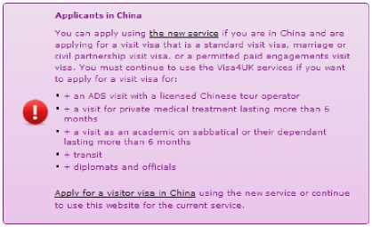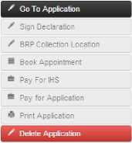

family are applying. It is reasonable to choose a date around 3months from the date you intend your family to attend the embassy.

6. You will be asked what type of application you are making. In the ‘Select visa type' section, key in the following:

**>** Settlement

**>** Settlement

**>** Family Reunion - Part 11 Asylum, Immigration Rules.

7. Click on **Create application.**

8. You have created an application for your family member. You can now start to complete the application by clicking on ‘Go to application'.

**Remember: You need to complete separate application forms for each family member.**

Please note: you can select a ‘help' language option, which will explain the questions in a column on the right-hand side of the computer screen in a language of your choice.

When completed you will see something like this:

My applications

Status:

**Incomplete**

Next Step: GoTo Application

Applicant:

**Test McTest**

Reference:

**GWF03S243693**

Travel Date:

Settlement

31 Jan 2016

Application Started:

23 Nov 2015

Family reunion - under Part 11 Asylum, Immigration Rules

Completing the online application

To complete the online application form, you will need all your family members' details - this includes full names, dates of birth, addresses, travel history and address history. (You will also need the parents' full details: names, dates of birth, places of birth and nationality).

You can save your application as you progress. However, do not click confirm application until you are 100 per cent satisfied that all the information is correct and you have answered each question.

**Remember: you are the Sponsor and your family are the Applicants. The form should be completed as if your family were completing it.**

The form is a general settlement form for all kind of visas, so it is very important to make clear that your application is for refugee family reunion at every opportunity.

When completing the online application form, have the following information to hand:

***J*** Passports (copy of your family's and your own, if you have one).

***J*** Refugee status documents.

In order to complete the online form you will need to know the following information about the applicant(s):

**Creating application and ‘passport / travel document' sections**: All their passport details including passport number, issuing authority, issue date and date of expiry. You will also need to know what has happened with old passports they held before.

If your family members **do not** have passports, enter ‘NO PASSPORT' or ‘NOPASSPORT' for questions about passport number and issuing authority questions. For the date of issue / expiry, you can put 01.01.1900 and 01.01.2100.

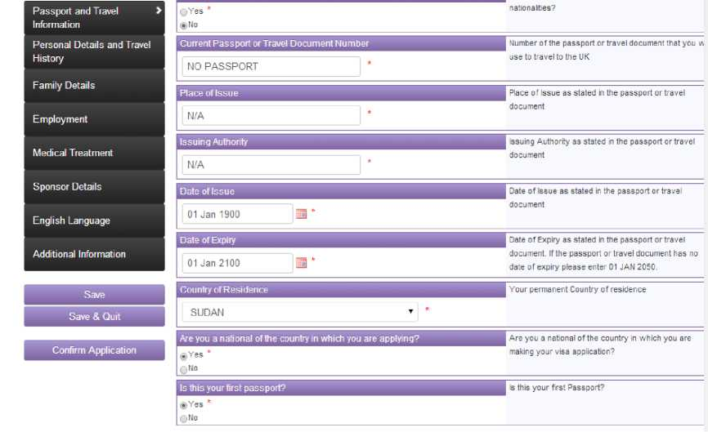

**'Personal details and travel history' section:** The travel history of the family members, including any previous travel to the UK and / or travel outside of their country of residence. You will need to know when and where they went, the amount of time spent away and the reason for the journey (study, holiday etc.).

**‘Family details' section:** The names, dates and place of birth, and nationality of the spouse, mother, father, dependent children and non-dependent children of every family member who is applying.

In the ‘family details' section, you are asked about your marital status. If you are married / a civil partner or an unmarried partner, you are asked for details about your partner / husband / wife. If it is your partner / husband / wife who is applying to come to the UK to join you,include **YOUR** passport details, name and address - and NOT those of your partner / husband / wife.

**‘Employment' section:** You need to have details of the applicant's current work status

(including which school they attend, if they are in education).

**‘Sponsor details' section**: Please remember that this is about you, as **you are the sponsor**: your address, contact and passport details need to be entered here. In the ‘sponsor details' section, you are unable to choose ‘wife', ‘husband' or ‘spouse' or ‘parent' to describe the relationship between the applicant and yourself. Instead, choose ‘Partner' if this is applicable or ‘Other relative' and explain in the additional information section what your exact relationship is.

Passport and Travel Information

Personal Details and Travel History

Family Details

Employment

Medical Treatment

Sponsor Details

English Language >

Additional Information

Save

Save & Quit

Confirm Application

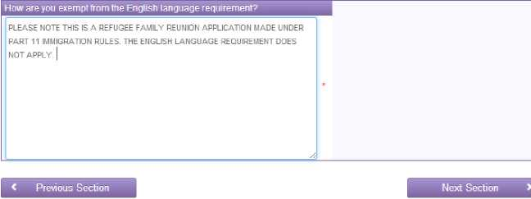**‘English language' section:** If you are making a refugee family reunion application, your family will be exempt from having to meet the **English language requirement**. The English language requirement is not a condition for refugee family reunion applications.

English Language

Are you exempt from the English language requirement?

®Yes *

ONo

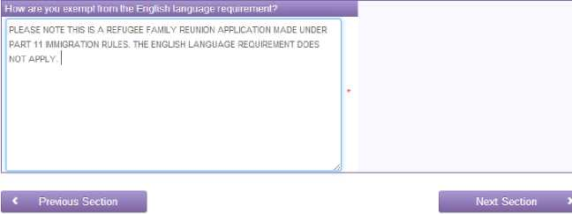

English Language

Are you exempt from the English language requirement?

®Yes *

ONo

Passport and Travel Information

Personal Details and Travel History

Family Details

Employment

Medical Treatment

Sponsor Details

English Language

Additional Information >

Save

Save & Quit

Additional Information

Is there any other information you wish to be considered as part of your application?

PLEASE NOTE THAT TH IS IS A REFUGEE FAMILY REUNION APPLICATION MADE UNDER PART 11 IMMIGRATION RULES.

PLEASE NOTE THAT NEITHER I NOR MY SPONSOR HAVE PASSPORTS. WHEN PASSPORT DETAILS WERE REQUESTED WE HAVE ENTERED NO PASSPORT AND DATES 01.01.1900 AND 01.01.2100 IN ORDER TO ALLOW US TO COMPLETE THE FORM. WE REQUEST THAT SHOULD VISAS BE GRANTED THEY ARE ISSUED ONA UFF TO ALLOW US TO TRAVEL.

PLEASE REFER TO ADDITIONAL EVIDENCE AND REPRESENTATIONS INCLUDED.

PLEASE CONTACT ME ON 020202020202 OR EMAILTESTMCTEST@TEST.COM IF YOU HAVE A^Y QUESTIONS.

THANK YOU.

Is there any other information you wish to be considered as part of your application?

Settlement - Settlement - Family reunion - under Part 11 Asylum, Immigration Rules

Passport and Travel Information

Personal Details and Travel History

Family Details

Employment

Medical Treatment

Sponsor Details

English Language >

Additional Information

Save

Save & Quit

Confirm Application

**‘Additional information' section**: Use this space to explain anything in the forms that may not be clear in your application (for example: the fact that you or your family have no passports). Also use this space to explain any inconsistencies in the form and the application, or any missing paperwork and documentation. You could also mention that the application is a refugee family reunion application.

Settlement - Settlement - Family reunion - under Part 11 Asylum, Immigration Rules

Signing the declaration

When you have created and fully completed an online application for every family member, you will need to confirm the application and then **sign the declaration online.** You can sign the declaration yourself as you were the person who completed the application form. Your family will need to physically sign a print-out of the online form before they give the application bundle to the embassy.

BRP Collection Location

You will be required to register your family to collect their Biometric Residence Permit from a particular post office. Usually the post office is one which is close to your address in the UK but it is not necessarily your local post office.

**Biometric Residence Permit (BRP) Collection**

If you are granted leave to enter the UK for over six months, you will be given a BRP as proof of your leave and conditions of stay. You can read

more about the BRP here <https://www.aov.uk/biometric-residence-permits>.

If you enter a UK postcode you will be assigned to a Post Office. If neither your Sponsor Address Postcode nor Residential Address Postcode

gives you a suitable Post Office branch, you may enter another UK postcode in the ’Alternative Location’ field.

You can find details of the location and opening hours of any Post Office branch here: <http://www.postoffice.co.uk>.

If your sponsor offers collection from their own site, rather than the Post Office, they will have told you to use an **ACL code.** Please enter that code

in the '’Alternative Location’ field. Your sponsor will tell you about the opening hours of their collection point.

**If you are applying to enter a Crown Dependency (Jersey, Guernsey or the Isle of Man) you will not be given a BRP and will not need**

**to visit a Post Office branch. If this applies to you, please enter SW1H OAX in the “Alternative Location” field.**

Alternative Location:

® | LS12 2LB

Flnd I

Your assigned collection location:

Post Office - Armley

9-11 Town Street

Armley

Leeds

LS12 1UX

Please note: It is important that if your family are granted visas they go and collect their biometric residence permit from the allocated Post Office **within 10 days of arriving in the UK**. Information on the Biometric Residence Permit is available here: [https://www.gov.uk/government/uploads/system/uploads/attachment data/file/440255/Final](https://www.gov.uk/government/uploads/system/uploads/attachment_data/file/440255/Final_-_v.9_overseas_BRP_leaflet.pdf) [- v.9 overseas BRP leaflet.pdf](https://www.gov.uk/government/uploads/system/uploads/attachment_data/file/440255/Final_-_v.9_overseas_BRP_leaflet.pdf)

Booking the appointment

You will need to book appointments at the **Visa Application Centre (VAC)** for every family member. Booking the embassy appointment can only be done after you have completed the online application.

Click on ‘book appointment' and choose the relevant embassy, then specify the type of appointment you require (normally this is either “Standard Appointment” or “Enrolment Appointment”) and the time.

Select your appointment location

You must now book an appointment to submit your biometric data as part of your visa application. The available appointment location(s), according to the information you have provided, are shown below. If multiple appointment locations are shown, you may choose the most convenient location.

|  |  |
| --- | --- |
| Country | SUDAN |
| Region | Khartoum ▼ |
| Appointment Location | Khartoum ’ * |
| Visa Appointment Type | | Enrolment Appointment T | |

Appointment Location

British Embassy Khartoum

Visa Section

Off Sharia Al Baladiya St

Khartoum East

PO Box 801

Telephone: (+249) 183 777105

Visa Appointment Messages

Select Appointment Date And Time

Please select an appointment to submit your biometrics and/or submit any supporting documentation

**Available Appointment Times**

**Available Days**

Your Visa Application Centre

British Embassy Khartoum

Visa Section

OfF Sharia Al Baladiya St

Khartoum East

PO Box 801

Telephone: (+249) 183 777105

Confirm the date and time of the appointment, then **print the appointment booking details** and include them in the bundle of documents.

**Please note**: you may have to register your appointment on the VAC website also. You will be prompted to do this as it is now part of the online forms “check-list”. Please ensure you register your appointment on the appropriate website.

Registering for your Immigration Health Surcharge Reference number

You must register for an IHS reference number, and will be automatically prompted and redirected to do this during your online application once you have booked your online appointment. The link from the main menu on the application homepage is titled “**Pay for your IHS**” however you **will not** be required to pay a fee if you are making a family reunion application.

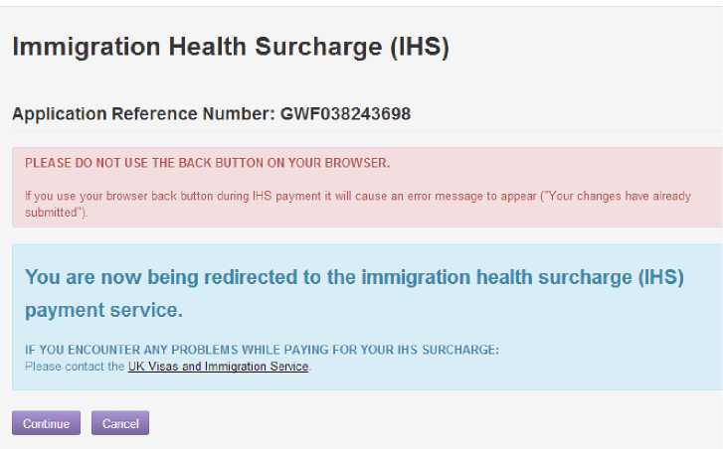

You need to enter your family members details.Once done, on the next page you will be asked whether the family member is applying to remain with someone already in the UK. You need to enter your own details as the sponsor here:

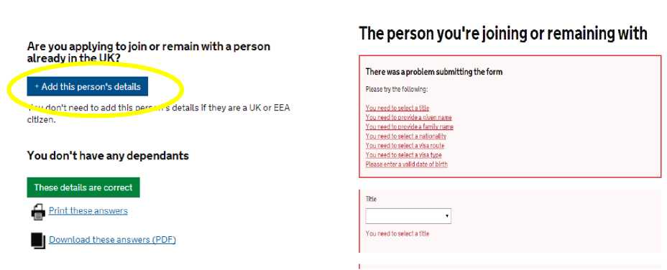

Visa route is **“Settelement”** and visa category is “**family reunion -under part 11 Asylum, Immigration rules**”.

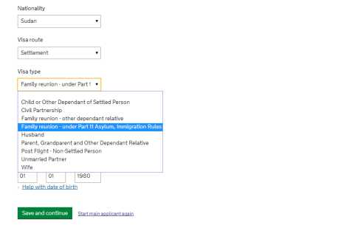

When completed, you will receive a payment summary and an HIS reference number that you should write on the front of the application forms and/or cover letter for each applicant. It will always start with “IHS”.

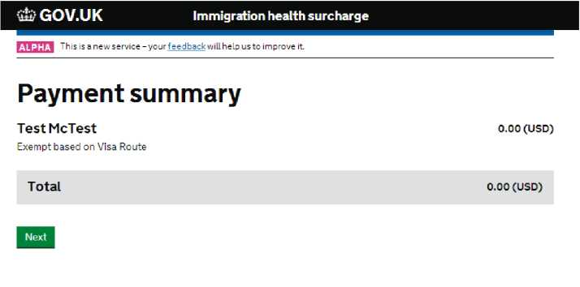

Status:

Complete

Next Step:

Print Application

Settlement

Family reunion - under Part 11 Asylum, Immigration

Rules

Registering with the Visa Application Centre / Commercial Partner

If required, you may need to register with the embassy's commercial partner website before compiling your application bundle and attending the embassy appointment. This is distinct from booking your online embassy appointment.

Registering with the VAC depends on the particular VAC your family will be attending. For example, at the time of writing, you have to register online if you are attending the embassy in Turkey, but not if you are attending in Khartoum. If you have to register a link will show on your online application which says “**Register at Commercial Partner**”.

Application Completed

* Declaration Signed

BRP Collection Location

View Appointment

IHS Payment Completed

Payment Not Required

•z Register at Commercial Partn

S Print Application

The corporate partners of the UKVI that operate the front desk services at the visa application centre will often allow you to track your application. Either they will email you with updates or you can login and track the application directly. Failure to register in advance of attending the embassy appointment may result in delays on the day.

TLScontact operate a system where you register online and can track your application however VFS global are also partners with UKVI, but do not offer an opportunity to register online and track your application.

To register you can follow the link from your online form (see above) or you can visit <https://www.gov.uk/find-a-visa-application-centre>and select the country in which you are applying.

Remember not all VACs require you to pre-register.

Printing your application(s) and appointment details

After you have booked the appointment, you should be able to **print the online application forms** as well. It is important to print the entire online application form for each family member and include this in the evidence bundle. It sometimes takes an hour after completing the online form before you can successfully print the form.

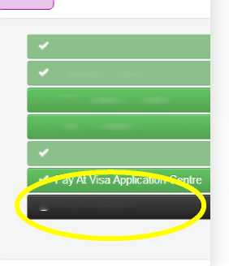

Application Completed

Declaration Signed

✓ BRP Collection Location

*<S* View Appointment

IHS Payment Completed

A Print Application

Online forms in summary

1. **Register for an account > login> apply for someone else.**
2. **Fill in the online application form as if you were your family member abroad > when finished, confirm application.**
3. **Sign declaration.**
4. **Book appointment (standard) at the Visa Application Centre (VAC) or relevant embassy.**
5. **Obtain Immigration Health Surcharge reference number**
6. **confirm this appointment on the VAC website**
7. **Print your online application form and appointment details, and include in your bundle.**

**Appendix 4 (pre-flight family reunion) application form**

You should print the Appendix 4 (pre-flight family reunion) form. This form asks for details on your family relationship. **You will need to complete an Appendix 4 for every family member who is applying.**

**>** If you are applying for a partner, complete parts 1, 3 and 4.

**>** If a child is applying, complete part 2, 3 and 4.

When completing the Appendix 4 form, it would be helpful to have the following documents and information close to hand:

**>** Marriage certificate.

**>** Death or divorce certificate (from any previous relationships).

**>** Passports of your family members and your own travel document.

**>** Birth certificates of your children.

In ‘Additional information', you can remind the Entry Clearance Officer that this is a refugee family reunion application - and provide a list of supporting evidence and documents you have sent.

‘Additional information' can also be used to give details not already provided in other sections, perhaps because there was not enough space to include all the information. (For example: sibling details from part 2 where there are more than four children).

**Remember**: if you run out of space on the form, you can attach additional pages. Just make sure to mention that you are doing this on the application form in part 4.

Form completion - Summary

1. Complete an online VAF4A application form for each family member and book appointment
2. Select a Post Office for family members to collect their Biometric Residence Permit from when they enter the UK
3. Register all family members for an NHS immigration health surcharge reference number.
4. Register all family members with the VAC website (if applicable).
5. Complete an appendix 4 application form for each family member.
6. Making your application bundle

I have completed the online forms and Appendix 4 form, and booked appointments for my family. What happens now?

* 1. Next steps

**> Print the completed online application form and appointment details** (for every family member) and add these to the evidence you have collected to make a **document bundle**.

**> Write the immigration health surcharge (IHS) reference number** on the top of the printed version of the application form and/or on the cover letter of your bundle.

**>** Your family will need **to sign the printed version of the online form** before going to the embassy. Make a note in pencil, use a sticky note or highlight where they need to sign (front and back) on the online form, so that they know where to sign.

**> Include completed copies of the Appendix 4 form** for every family member in your evidence bundle.

* **Photocopy** all the documents you have - applications forms, appointment details, translations, evidence etc. so that you have a record of what is in your application.
* If you need a TB test certificate, **make sure your family have the details of the local TB test centre** where they should go to get their TB test completed.
* Make sure your **family know what they have to do** when they receive the bundle of documents (see below).
* Finally, **post** the documents to your family abroad through a reputable courier service. You need to ensure that you post the documents to a **trusted address and leave plenty of time for delivery.** Remember to leave sufficient time for your family to complete their TB tests, and for you to send the bundle of documents to family members abroad. Three weeks is usually advisable, as this leaves sufficient time to post the documents (one week), for the family to do their TB testing (one week) and for them to get any additional evidence included in the bundle (translations, replacing photocopies with originals etc).
  1. Creating a bundle

Ensuring your bundle is ordered clearly and correctly will help the Entry Clearance Officer see that you have followed all the rules. It may be useful to use clear plastic pockets or wallets for each separate form and piece of evidence that you plan to submit, and to label these at the top (on the outside of the plastic wallet) stating what evidence is inside. (For example: Birth certificate for Sarah; Lycamobile records from Jan - Dec 2014; Money transfer receipts from Jan -March 2015.)

Put your cover letter at the front of the bundle. It is up to you to decide in which order to arrange your documents, but ensure that all translations are attached with their accompanying documents (either in the same plastic pocket or clearly labelled to show which document they relate to). Once you are satisfied the bundle is clearly labelled, and all your evidence and forms have been compiled, then photocopy your bundle.

* 1. Posting your documents

When you are ready to post your documents, ensure that you send them through a courier service and not by regular post. How much it will cost to post your bundle will depend on its size and weight.

Post the documents to a trusted address where your family can collect the documents. Do not post directly to the embassy.

Keep the receipt for your posted documents in a safe place. It can take anywhere between three to ten days for documents to be delivered to your family, so ensure you have left enough time before the embassy appointment for the documents to be delivered.

If you are applying from the following countries (at the time of writing) you will be required to post your application and supporting documents directly to the UKVI office in Sheffield:

1. Afghanistan

2. Pakistan

1. India

Please note this is not an exhaustive list. In these cases, the applicant will attend their interview in their country to provide their biometrics and then the sponsor or applicant will have 20 days from that appointment to post the documents to Sheffield. Please note the originals must also be sent. If you are unsure where to send your documents please check the TLS or VFC website for each country for further information.

**It is very likely that many more countries will be required to send their documents to Sheffield in the future. Please check the websites before sending documents to your family.**



1. Preparing for, and attending the embassy appointment

Your family will be obliged to attend the visa application centre or embassy at the date and time for which you have booked their appointment.

* 1. Your family must...

**> Sign and date the online application forms**. The online form needs signed and dated both at the front and at the back.

**> Replace any photocopies** with original documents where they are available.

**>** Include any **translations** done in their country with the original document in the bundle.

**>** Ensure your family have arranged for their **TB test** if necessary, and have the required fee and documents to bring to the test. Attend the TB test appointment and collect their TB test certificate. Include this in the document bundle

**>** Know the **date and venue of their appointment** at the Visa Application Centre / embassy.

**>** Be prepared to be asked questions **at interview** at the Visa Application Centre.

* 1. What happens at the overseas mission / embassy?

The Visa Application Centre (VAC) is a commercially run organisation, which operates a ‘front-desk' for the Entry Clearance Officers of the Home Office.

Your family need to attend the VAC at the appointment time given and hand over all of their documents.

**Your family may be interviewed at the embassy.** They could be asked to discuss their relationship with you, and when you last saw each other etc. It is important that your family understands in advance that this could happen and are prepared. However, this interview can be a good opportunity for them to explain in their own words why they want to join you, the sponsor, in the UK.

When the documents are handed over, they are often photocopied and the originals retained to be returned to you at a later date.

If your family are making their application in a country where they do not usually live, they can ask for their passports to be returned to them so that they can travel back home. (Note: this may need to be arranged in advance with the embassy, and the reason given.)

* 1. Changing or cancelling embassy appointments

In the event that you need to change the appointment date for your family, you can normally do this by logging into the online **visa4uk** website. Go to the ‘Book appointment' section for each family member.

You can then chose to either change your appointment (if you need to move the date) or cancel your appointment (if you no longer wish to attend the embassy to make the application).

**How to change your appointment**

Follow these steps:

> Update appointment > Select embassy venue > Standard appointment > Select a new date and time > Confirm > Print off new appointment details.

It is worth bearing in mind that making changes to appointments may not be possible immediately before your appointment is due to occur. Also, the Home Office periodically suspends the ability to do this if (for example: if they are making changes to the visa4uk website). If you do need to change your appointment, try to do it as far in advance as possible.

* 1. I have missed my embassy appointment

If you miss your embassy appointment, it may not be possible to rearrange it online. If this occurs, you may have to follow the process to re-apply online and book entirely new appointments. You would need to ensure your family had copies of the new online application and appointment details.

1. Decisions and outcomes

8.1 How will I know when a decision has been made?

The embassy will send a notification to tell you that a decision has been made. This often arrives in the form of an email. Usually they **will not** tell you whether the decision is positive or negative before you go to collect your documents.

It is worth noting that it takes several months for decisions to be made. Decision times do vary between various embassies: however, the embassy officially has up to 90 days to make a decision. If you wish to check how long your specific embassy generally takes to make a decision, visit:**[https://www.gov.uk/VISA-processing-times](https://www.gov.uk/visa-processing-times)**[.](https://www.gov.uk/visa-processing-times)

If you have not heard anything within 12 weeks / 90 days of submitting the application, you should contact the embassy.

1. What happens if my visa(s) are approved?

If your visas are approved, your family needs to attend the embassy to collect each of the passports with the visa in place, or to receive the one-way travel document with the visa attached. They will be given a date after which the visa can be collected.

If your family made an application in a country other than the one in which they live, they will need to travel to the relevant embassy to leave their passports - **sometimes the embassy will ask that they do this within 14 days of the request.** It can take several days for the visa to be issued in their passport, so such families may have to arrange accommodation in the embassy country for up to seven days.

Once the visa(s) have been received, you can start to make travel arrangements. You may wish to enquire about the British Red Cross family reunion travel assistance programme.

**Please note that most visas issued under family reunion are valid for only 30 days.**

Your family must be able to enter the UK within these 30 days. If they do not enter within the 30 day period on their visa they will have to re-apply for another visa. The Home Office guidance refers to 30 day validity with the option of it being deferred for up to 3 months.

Once they have entered the UK they must collect their Biometric Residence Permit from the Post Office you selected when you completed the online application form. This information should also be on the letter they receive when they attend the embassy to collect their visa. The Biometric Residence Permit should give them leave to remain in the UK in line with your own status as a refugee. It is important to check the Biometric Residence Permit and ensure all details are correct. If not please notify UKVI immediately.

What is family reunion travel assistance?

The British Red Cross family reunion travel assistance scheme pays for and arranges travel to reunite refugee families. The scheme organises and pays for family members' travel to the UK only.

The service is for people who:

* already have family reunion visas for their families to enter the UK
* earn less than £240 a week, before tax and rent, or get means-tested benefits.

Once the family reunion visas of your family members are in place, contact your local Red Cross office for an appointment to apply for travel assistance.

If the application is accepted, the Red Cross will work with the International Organisation for Migration (IOM) to organise your family's travel. **The scheme cannot refund tickets that you buy privately and cannot give you cash to buy tickets.** It currently takes around **six weeks** from the application being made until the family member(s) arrive in the UK. Some applications can take much longer. The scheme has limited funds and approval of applications is not guaranteed. The criteria can change, so please contact your local Red Cross office for more information.

**Email:**[Familyreunion@redcross.org.uk](mailto:Familyreunion@redcross.org.uk) **Tel:** 020 7877 7292 or 0207 877 5029

What else do I need to think about before my family arrive?

Preparing for your family to arrive in the UK is an important step. You will have a lot to think about, including the following:

***J* Housing** -will you need to move to accommodate your family?

***J*** Do any of your family members have special requirements in terms of housing (for example: difficulty with stairs; requirement to be near a hospital, park or school?)

**J Education -** do any of your family members need to be enrolled in school? Have you looked into English classes?

**J Health -** can you register your family member(s) at your doctor, and do they have  
any special medical issues that need to be checked immediately after arrival?

**J Recreation activities -** where would you want to take your family, and where could they meet other people who might become their friends?

Preparing your family for their new home

It might be a good idea to send pictures of where you live to your family members (if you haven't already), and to describe your local area. Children might like to see postcards of nearby places, and learn a few basic words if English is not their first language. There are some great value language books available that you could send over. Your family might want to start buying clothes and shoes to suit a different climate.

1. What happens if my family members' applications are rejected?

Appeals

If the Entry clearance Officer (ECO) refuses to grant a visa for any or all applicants, you have the option of **appealing** their decision. This can take many months, but the case will be heard in a UK based tribunal. For more information, visit: [www.justice.gov.uk/tribunals/immigration-asylum](http://www.justice.gov.uk/tribunals/immigration-asylum)

It is very important that you **lodge an appeal**, along with the appropriate payment (preferably online via the above website), within the **28-day timeframe**. These 28 days start from the date when your family receive the notice of refusal. (Note: you will have 56 days to appeal if the refusal notice was posted.)

An appeal form - **an IAFT 6** - will be attached to the refusal notice and needs to be completed within 28 days of your family members receiving the refusal notice. The form can be found here: <https://www.gov.uk/immigration-asylum-tribunal/appeal-from-outside-the-uk> Following recent changes in the law, you can only appeal on human rights grounds. The relevant human rights ground for family reunion appeals will normally be Article 8 of the European Convention on Human Rights:

**Article 8 - Right to respect for private and family life**

1. Everyone has the right to respect for his private and family life, his home and his correspondence.
2. There shall be no interference by a public authority with the exercise of this right except such as is in accordance with the law and is necessary in a democratic society in the interests of national security, public safety or the economic well-being of the country, for the prevention of disorder or crime, for the protection of health or morals, or for the protection of the rights and freedoms of others.

All parts of the form need to be completed. You need to write down anything you think the ECO has got wrong, and state why it is wrong. If you have extra evidence (more proof of contact, DNA evidence, statements or letters etc.) you can submit it with this form.

**The appeal process can take between 12 - 18 months.**

When you lodge your appeal, you need **to tell the court if you want an interpreter**. Be clear about the language and dialect you speak, and whether you would prefer a male or female interpreter.

It is always preferable to have a professional representing you during an appeal. However, if you are not able to find one, you can represent yourself at the hearing. You can decide to have the appeal heard in person (this means you attend court) or ‘on papers' (where the judge makes a decision without meeting you). It is generally considered better to be present at court and appeal in person, since you can then respond to questions from the **Home Office Presenting Officer (HOPO)** or **judge** in your own words.

If you decide to represent yourself, you may want to read this guidance from the Bar Council: <http://www.barcouncil.org.uk/media/203109/srl_guide_final_for_online_use.pdf>

You can also consider asking for help to be referred to the Bar Pro Bono Unit: **[enquiries@barprobono.org.uk](http://www.barprobono.org.uk/new_contact_us.html)**[.](http://www.barprobono.org.uk/new_contact_us.html)

What does a hearing room look like?



|  |  | Judge |  |
| --- | --- | --- | --- |
|  | | |
|  | You Interpreter  (If needed) | | |

Will I be asked to speak?

You will be questioned by the judge, Home Office presenting office and your own lawyer if you have one. You can have an interpreter who will help you communicate to court. The court is a very formal setting and you should dress appropriately and remember that the Judge is addressed as “Sir” or “Madam”. It is important to understand that in court, it is better to say “I don't remember” or “I don't know” when you are unable to answer a question rather than fabricate something.

Will the judge give a decision on the day?

The judge will most likely not make a decision on the day. Instead you or your representative will have to wait until she/he promulgates (sends out or hands down) a decision.

What decisions can the court make?

The appeal is upheld

If the appeal is “upheld” this means you have won your appeal and the Home office will be asked to grant the VISA. They will send this request to the Entry Clearance Officer

The appeal is dismissed

If the Appeal is “dismissed” this means that the appeal has not been successful, and you will need to decide whether to appeal again to the Upper Tribunal on a point of law error, or whether to make a fresh application at a future date.

Adjourned

The court can decide to adjourn your case during the hearing either because it has run out of time or because more information is needed or one of the parties needs to consider fresh evidence or take instruction. It can also be adjourned if one of the parties has not attended.

Home Office withdrawal

It is also possible for the Entry Clearance Officer or Manager or the Home Office to withdraw their refusal notice **at any point** during the appeal process. This means that no decision need be made by the judge. The VISA in this case should be granted by the Entry Clearance Office in the Embassy where your family submitted their application. However, this is not automatically done. In this situation, there is no court decision which means that the ECO at the embassy could refuse the application again however; if this is the case there would be good reason to appeal.

It is also possible that the Home Office can withdraw one refusal notice only to revise their decision and give new or amended reasons for refusal.

Reconsideration

When an application has been refused, you or an advisor may also seek a **review or reconsideration** of that decision. To do this, contact the embassy or High Commission directly and in writing. New evidence that responds to the points in the refusal notice can be sent with the request. Once the review request has been received, the case will be passed to the **Entry Clearance Manager (ECM)** who will review the case and the decision of the Entry Clearance Officer. They will decide whether the original decision should remain or be over-turned, or if further information or evidence is needed.

Making a fresh application

You can also make a fresh application: sometimes, this can be the best and quickest option.

|  |  |
| --- | --- |
| Summary  You can: | This might be the best option if: |
| 1) Appeal the decision. | There is an issue of **credibility**, or a complicated legal area. |
| 2) Ask for a reconsideration. | There are missing documents; DNA test needed. |
| 3) Submit a new application. | Numerous refusal points (ie: incomplete application). |
| .. .or a combination of the above. |  |

Glossary

Appeal - This allows you to take your case before an impartial judge who will decide whether the Home Office was correct in refusing a visa to your family members. The appeal is heard in the UK.

Appeal hearing notice - A letter you will receive after lodging your appeal, which will confirm that you have an appeal.

Appendix 4 - This is the paper form you must print and complete for every family member who is applying to join you in the UK. It asks for details regarding your family relationships.

Applicants - This is the term used to describe your family. In family reunion cases, your family are known as the ‘applicants' because they are applying to join you in the UK.

British embassy / Consulate - These represent the UK government abroad. The decision on your family reunion visas will usually be taken in a British embassy or consulate.

British Red Cross caseworker - A British Red Cross caseworker can help you prepare for lawyer's appointments, understand general information about family reunion, and solve any problems that might arise with your application. You do not need a Red Cross caseworker to apply for family reunion.

Certified - When you are unable to send original documentation, you may need copies to be ‘certified as a true copy' by a solicitor or notary public. It is important to note that the person signing is not saying that the document is genuine, just that the copy is a true copy of the document.

Credibility - Whether the Home Office choose believe you.

Discretion -The Secretary of State may choose to exercise discretion in particular cases if there are serious reasons why someone should still be allowed to enter or stay in the UK despite not meeting the requirements of the Immigration Rules. This is very rare in family reunion cases.

English language requirement - Some visa applications require your family to speak and understand a certain amount of English. Family reunion applications do not have this requirement and your family do not need English language skills to apply.

Entry Clearance Manager - This person is responsible for managing an Entry Clearance Officers' work. An ECM will re-examine your refusal before appeal.

Entry Clearance Officer (ECO) - This is a person who works for UKVI at the British embassy and is usually the person who will make a decision about your family reunion VISAs.

Exceptional case funding - This is a type of legal aid available in limited ‘exceptional' circumstances.

Financial and accommodation requirements - Some visa applications require that you are able to financially support and accommodate your family members, and you must prove this as part of your visa application. These requirements do not apply to refugee family reunion applications.

Home Office guidance and policy documents - These guidance and policy documents are not the same as UK law, but the Home Office uses them for guidance when it is uncertain how to interpret particular Immigration Rules. Immigration Rules take priority over guidance.

Home Office Presenting Officer (HOPO) - This is the legal representative who will represent the Secretary of State for the Home Office in an immigration tribunal hearing.

ICRC - This is the International Committee of the Red Cross, which provides help to people who are victims of war and violence. It works to try and put people back in touch with their families. The ICRC has offices all over the world.

International Organisation for Migration (IOM) - This organisation works with the British Red Cross on its travel assistance project. If you apply for travel assistance with the British Red Cross, it will be someone from IOM who calls your family to arrange their flights and help them on their journey. IOM have offices all over the world.

Immigration Rules - These are the rules that state who can enter and stay in the UK, and under what circumstances.

Judge - In any Immigration Tribunal, the judge is impartial and independent from the Home Office. The judge must follow the law as it applies to your case, and will decide your case.

Lawyer / Solicitor - Your lawyer (sometimes called a solicitor) can tell you whether you and your family have a right to family reunion, explain what you need to do to apply for family reunion, and help you to prepare an application. They must be qualified to do this. It is possible to make an application for family reunion without a lawyer, but it is always best to get advice from a lawyer if you can.

Lodge an appeal - If you wish to appeal against the Home Office's decision to refuse your family member a visa, you must ‘lodge' an appeal. This requires you to submit form IAFT-2, along with your appeal grounds and tribunal fees.

Not leading an independent life - This is defined in the introduction to the Immigration Rules as: ‘the applicant does not have a partner as defined in Appendix FM; is living with their parents (except where they are at boarding school, college or university as part of their full­time education); is not employed full-time (unless aged 18 years or over); is wholly or mainly dependent upon their parents for financial support (unless aged 18 years or over); and is wholly or mainly dependent upon their parents for emotional support.'

Notice of decision to refuse entry clearance - This document is received by applicants, either by post or in person at the embassy, when their application for family reunion is refused. Normally, an IAFT-2 form is also provided.

Part 11 asylum Immigration Rules - Where the rules relating to family reunion can be found.

Pre-existing / Pre-flight family - This means family members who you normally lived with before you had to leave your last country of residence. It is normally defined as people you are related to who lived in the same house as you, and / or that you supported financially, emotionally and practically. Both terms are used. However, the correct term is pre-flight.

Review and or reconsideration - If your application is refused, you can ask the Home Office to review or reconsider the decision. This essentially asks them to check the documents they received, and that their reasoning is in line with the Immigration Rules. It is not the same as ‘appealing' a case, as the review is conducted by the Entry Clearance Manager and not an Immigration Appeal Tribunal judge.

Secretary of State for the Home Office - This is a senior member of the government who is responsible for regulating all immigration to the UK. They have the power to make decisions outside of the Immigration Rules, provided that the decision is not illegal under UK law.

SET10 - This is Home Office guidance around refugee family reunion. The guidance document is used by the Entry Clearance Officer when they make the visa decision.

Sole responsibility - This is an issue that sometimes needs to be looked at carefully in cases involving children. Having sole responsibility for a child requires you to show that you have been solely responsible for making important decisions in a child's life and ensuring their welfare. This is particularly important if the other parent of the child is not planning to join you in the UK.

Sponsor (person in the UK) - In family reunion cases, you are known as the sponsor.

Subject access request - This is an application that you can make to get information or documents from the Home Office.

TB test - The UK requires people who are planning to stay in the UK for longer than six months, and who are applying from certain countries, to undertake a tuberculosis screening test

UNHCR - This is the United Nations High Commissioner for Refugees. UNHCR provides protection and assistance to the world's refugees. It is a non-political organisation and has offices all over the world. You might need help from them if your family have had to flee their home country and are living somewhere else before they join you in the UK.

UK Law - In this context, we use UK law to refer to those laws made by or approved by the British parliament. UK law can also include binding decisions made by courts, which act as precedent.

UK Visas and Immigration (UKVI) - This is the department of the Home Office that decides who can come into and remain in the UK.

UFF (Uniform Format Form) - This is a one-way travel document issued in particular circumstances, such as when a visa is granted but it is not possible for the applicant to obtain a passport.

VAC (Visa Application Centre) - The VAC takes people's visa applications and passes them to the Entry Clearance team to make a decision on the visa. This is where your family will go to submit their family reunion applications.

Valid marriage - This is a technical legal term used to determine whether a marriage is lawfully recognised under UK law. Typically, a marriage is ‘valid' if it was legally recognised in the country where it took place, when it occurred.

Visa - This is the document that grants you entry to the UK.

Witness statement - This is a document recording the evidence of a person, which is signed by that person to confirm that the contents of their statement are true.

57